Quick Guide Page
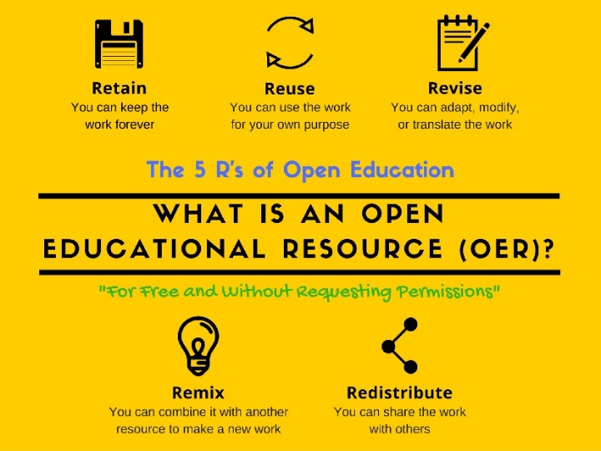
Definition of Open Educational Resources
“Open educational resources (OER) are any resources available at little or no cost that can be used for teaching, learning, or research. The term can include textbooks, course readings, and other learning content; simulations, games, and other learning applications; syllabi, quizzes, and assessment tools; and virtually any other material that can be used for educational purposes. OER typically refers to electronic resources, including those in multimedia formats, and such materials are generally released under a Creative Commons or similar license that supports open or nearly open use of the content. OER can originate from colleges and universities, libraries, archival organizations, government agencies, commercial organizations such as publishers, or faculty or other individuals who develop educational resources they are willing to share.”- 7 Things You Should Know about Open Educational Resources, EDUCAUSE, 2010.

What is OER? 2min video, The Council of Chief State School Officers, 2016.
What does the research say about OER? 3min video, The Council of Chief State School Officers, 2016.
Open Access Directory, is a compendium of simple factual lists about open access (OA) to science and scholarship, 2019.
Open for Students AND Educators: Open Education Resources Level the Playing Field, Webinar for ACRL, Oct. 22, 2019. 55 minutes.
Library Guide to Open Access in Higher Ed from ACRL. Open Access Policies Intro Video.
OER Commons, ISKME, the Institute for the Study of Knowledge Management in Education. Search 176 university and organization created open license textbooks. Open Author publishing tool: Module Builder to create interactive modules for higher education, Resource Builder. Full University Courses Publishing Tool: Open Author Collections by Subject Area

Search for OERs available online by Repositories, Open Textbooks, Books, Open Courseware, Open Access Journals, Subject Specific, Digital Media from Community College Consortium for OERs (CCCOER)
Five Steps to OER Adoption, CCCOER. Includes rubric for evaluating the OER, license considerations, delivery to students, etc.

Search Engines for Textbooks and OER Courses
Serendipity, Linked Open CourseWare Data Faceted Search Engine, Computer Science Research Institute, Ecuador. Search for complete courses or individual lesson plans
Internet Archive Open Library, Textbook Search, supported by California State University
OpenStax CNX, Rice University, Houston, Texas. Peer-reviewed textbooks in multiple formats
Course Search Engine, Integrated database of the Open Education Consortium and MERLOT
OER Commons, ISKME, the Institute for the Study of Knowledge Management in Education. Search 176 university and organization created open license textbooks. Open Author Publishing tool: Module Builder to create interactive modules for higher education, Resource Builder.
Full University Courses Publishing Tool: Open Author Curated Collections by Subject Area
Community College Consortium for OERs (CCCOER)
Search for OERs available online by Repositories, Open Textbooks, Books, Open Courseware, Open Access Journals, Subject Specific, Digital Media

Open Access Academic Books, Not ONLY Textbooks
Directory of Open Access Books, All Academic, peer reviewed publishers, browse by subject

Videos Overviews of OERs
Council of Chief State School Officers, Open Educational Resources (OER), 2017.
An Introduction to Open Educational Resources, (4 min) Iowa State University library, 2017.
High Impact Practices for Integrating Open Educational Resources (OER) into University Courses, University of Buffalo, NY, 2016. 54 minute presentation.
Open for Students AND Educators: Open Education Resources Level the Playing Field, Webinar for ACRL, Oct. 22, 2019. 55 minutes.

Guides & Courses for Adopting an OER & Creating Policies
Five Steps to OER Adoption, CCCOER. Includes rubric for evaluating the OER, license considerations, delivery to students, etc.
Good practices for university open-access policies, Oct. 25, 2019. Berkman Klein Center at Harvard Univ.
The Coalition of Open Access Policy Institutions (COAPI). “Sharing information and resources to assist in the development and implementation of institutional Open Access (OA) policies. The COAPI Toolkit includes a diverse collection of resources that COAPI members have developed in the course of their OA policy initiatives.”
OER Guidebooks from BCcampus OpenEd (British Columbia, Canada): Adoption Guide 2nd ed. 2019, Print on Demand Guide, Faculty OER Toolkit, Adaption Guide
Webinars about OERs, CCCOER. Titles include: “starting OER Initiatives at your Institution”, “Regional Models for OER Implementation”, “Faculty OER Adoption Stories in Art History and U.S. History”, “Copyright and Licensing”, “Impact on Cost”, “Outcomes and Stakeholders”, etc.
Learning to (Re)Use Open Educational Resources Course, Peer 2 Peer University. “This open course will guide participants through the discovery, use and reuse of open educational resources (OER) for teaching purposes in all sectors of education. Together we will explore approaches to selecting and using materials that have been created by others, unpack the process of adaptation and discuss sharing and networking. This course will be highly attractive to both those who want to start using OER in their teaching and those who are already users but who are looking for an opportunity to create and share their own teaching resources for teaching.”
Becoming an Open Educator Course, Opening Educational Practices in Scotland. 20 hour course “is aimed at anyone who is curious about how free and open might change our approach to teaching and learning and has been designed for administrators, educators and facilitators in all sectors. This open course asks you to consider a range of questions. For example, how do I find open resources and what benefits might they bring? Does openness change the relationship to the content I create, the people I create content for, others with whom I share the material, and our own everyday practice and context? And if so, what impact, if any, does openness have on these practices and relationships?”
A Short Guide to Sharing Your Work, Ohio State University
“This book offers authors new perspectives on how to move forward with their work, including how they can make it easily accessible and affordable for their students. Written by two librarians, this title provides information on the various file formats for publishing, as well as copyright information.”- Book Description
Research About OER & Conducting Surveys for OER Planning
Research page from CCCOER. Includes video “Review of Effectiveness & Perceptions of Open Educational Resources As Compared to Textbooks”, links to U.S. university surveys of students, OER impact research webinars.
OERHUB, Researching Open Education, Open University, UK. Publications and effectiveness reports about OER. Includes: infographics based on effectiveness research, datasets, presentations, Researchers’ Guide, etc.
OER Research/Survey Toolkit, Open Textbook Network. Includes: guidebook, surveys for students, faculty, Sample Data Collection Template with Definitions.
“A Qualitative Investigation of Faculty Open Educational Resource Usage in the Washington Community and Technical College System: Models for Support and Implementation”. (PDF) Faculty usage of open Washington courses in 34 colleges research report. Washington State Board for Community and Technical Colleges, 2015.

OER Organizations
Open Education Consortium, the Global Network for Open Education
“The Open Education Consortium (OEC) is a non-profit, global, members-based network of open education institutions and organizations. OEC represents its members and provides advocacy and leadership around advancement of open education globally. OEC works with its members to build capacity to find, reuse, create and share Open Educational Resources (OER), develop open policy, create sustainable open education models, and enable international collaboration and innovation. OEC annually coordinates and hosts Open Education Week, the Open Education Global conference, and Open Education Awards for Excellence. Collectively these efforts aim to bring high quality, inclusive education to all learners around the world.”
Search for OERs available online by Repositories, Open Textbooks, Books, Open Courseware, Open Access Journals, Subject Specific, Digital Media
The Coalition of Open Access Policy Institutions (COAPI). “Sharing information and resources to assist in the development and implementation of institutional Open Access (OA) policies. The COAPI Toolkit includes a diverse collection of resources that COAPI members have developed in the course of their OA policy initiatives.”
Community College Consortium for Open Educational Resources
Saylor.org Academy. Offers free transferable college credit courses, all online. Course Catalog
University Based OERs
Bay College, Iron Mountain Michigan.
OER homepage, Courses and Textbooks, Resources
BCcampus OpenEd, British Columbia, Canada. Search Textbook collection.
MERLOT (Multimedia Educational Resource for Learning and Online Teaching), California State University
About MERLOT: “ The MERLOT collection consists of tens of thousands of discipline-specific learning materials, learning exercises, and Content Builder webpages, together with associated comments, and bookmark collections, all intended to enhance the teaching experience of using a learning material. All of these items have been contributed by the MERLOT member community, who have either authored the materials themselves, or who have discovered the materials, found them useful, and wished to share their enthusiasm for the materials with others in the teaching and learning community.
All the materials in MERLOT are reviewed for suitability for retention in the collection. Many undergo the more extensive "peer review" for which MERLOT is famous. MERLOT presents annual awards for various categories of materials added to or used in the collection. As described in Material Link Checking and Removal, all material URL's in the collection are reviewed frequently for stainability.”-MERLOT Collection Description
Some materials in MERLOT are Creative Commons and others are for a fee.
Finding Accessible OER by subject area
Examples: Philosophy of Western Religions, Introduction to Ethics
Also includes: Virtual Lab in Statistics, Bookshare- digital books for people with print disabilities.
MIT OPEN COURSEWARE, Massachusetts Institute of Technology
Homepage for Open Courseware, Find Courses, Educator Portal
Open Textbook Network, University of Minnesota. Open Textbook Network, Center for Open Education, College of Education and Human Development, University of Minnesota. PEER REVIEWED textbooks.
Open Michigan, University of Michigan. Finding OER resources and Publishing OER resources, including data, journal articles, sample exercises, lectures and presentations, etc.
OpenStax CNX, Rice University, Houston, Texas. Peer-reviewed textbooks in multiple formats.
TU Delft OpenCourseWare, Delft, Netherlands. Program is 10 years old. Courses are available in English. Bachelor level courses.
Student Advocacy
OER Student Toolkit, BCcampus Open Education, Victoria, British Columbia
Resource guide for Students to advocate for Open Education Resources in Higher Education
“The high cost of educational resources and textbooks create a serious obstacle to the accessibility and affordability of a post-secondary education. Traditional educational resources also present barriers to innovation in pedagogy and curriculum design. Fortunately, open educational resources (OER) are a viable solution to both these problems, since they can be accessed for free online or printed at a fraction of the cost of a traditional textbook and can be edited to better fit the curricular or pedagogical goals of an instructor.”-Book Description.

OER Software Providers
Lumen. Offers OER courses and software to support OER content. Waymaker: communication tools, texts and supplemental materials like embedded quizes, outcome analytics. Integrates into LMS including Canvas. Candela: ebooks with text, video, interactives, eTextbook replacement for $10 per enrolled student. Lumen OHM: thousands of interactive MATH and quantitative skills quizzes, digital homework system for hands-on practice, customizable courses.

